**IFT 266 Introduction to Network Information Communication Technology   
  
Lab 14**

**Routing with a Multilayer Switch**

Co-authored by Marc Herrero

**After you complete each step, put a ‘√’ or ‘x’ in the completed box**

1. Set up the following topology in packet tracer.

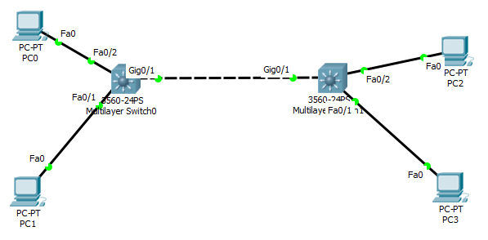



1. We will start with configuring swtich0 with a VLAN:

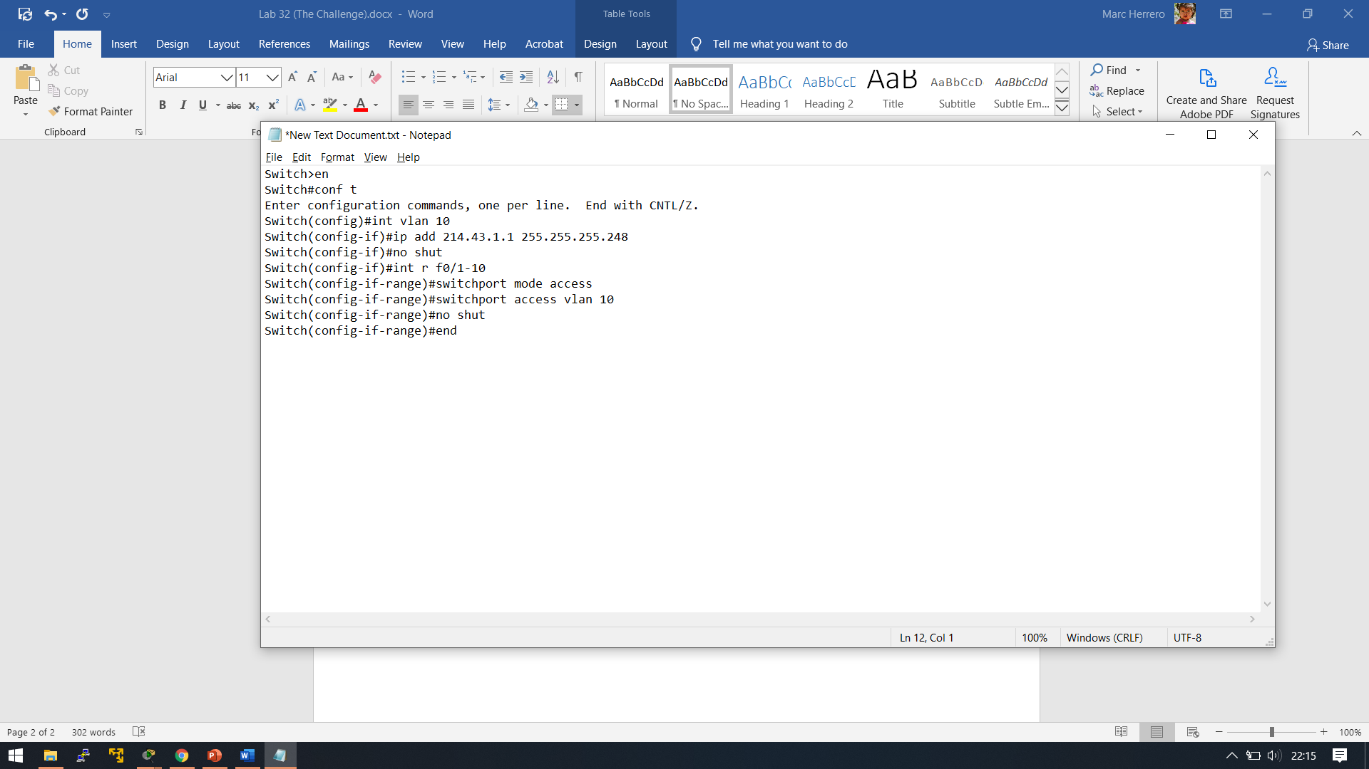



1. ****Configure switch1 with the same VLAN commands as you did for switch0, however, use VLAN 20 and the address/subnet mask 214.43.2.1 255.255.255.248.

1. Configure each PC with the following addresses, subnet masks and default gateway.

|  |  |  |
| --- | --- | --- |
| **PC** | **IP Address** | **Gateway** |
| PC 0 | 214.43.1.2/29 | 214.43.1.1 |
| PC 1 | 214.43.1.3/29 | 214.43.1.1 |
| PC 2 | 214.43.2.2/29 | 214.43.2.1 |
| PC 3 | 214.43.2.3/29 | 214.43.2.1 |



1. We have now configured the VLANs and the PCs. Verify these configurations with pings from PC0 → PC1 and from PC2 → PC3.   
     
   Insert a screenshot of one of the successful pings here.

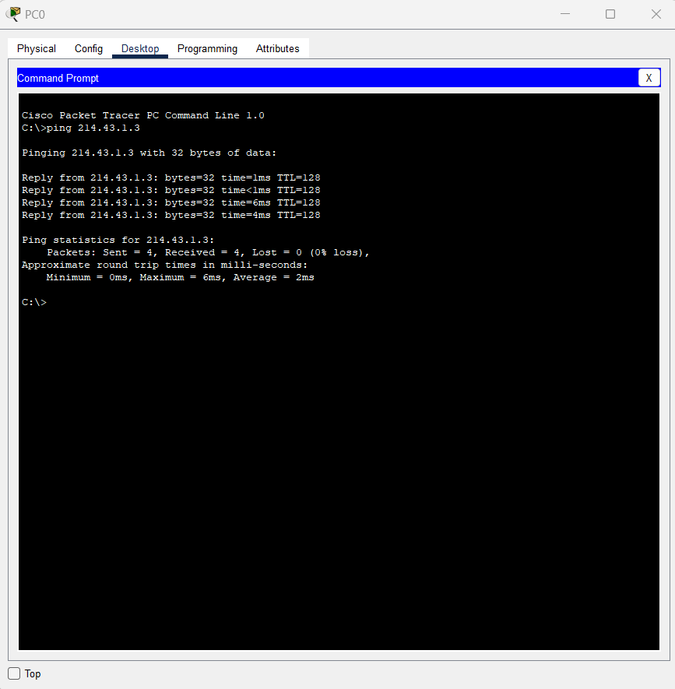

1. We will now configure the switch for layer 3 functionality.
2. We will start that process with configuring the g0/1 interface. As all ports on a multilayer switch are automatically configured as switchports which only allows layer 2 capabilities. In order to activate the layer 3 functions on the port enter the following the commands on switch0.

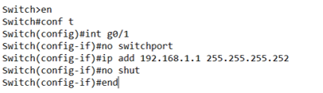



1. Repeat the same commands (from step 7) to configure g0/1 on switch1 with the address 192.168.1.2 255.255.255.252.



1. Verify you can ping each switches IP address from their directly connected PCs.   
     
   Insert a screenshot of one of the successful pings here.

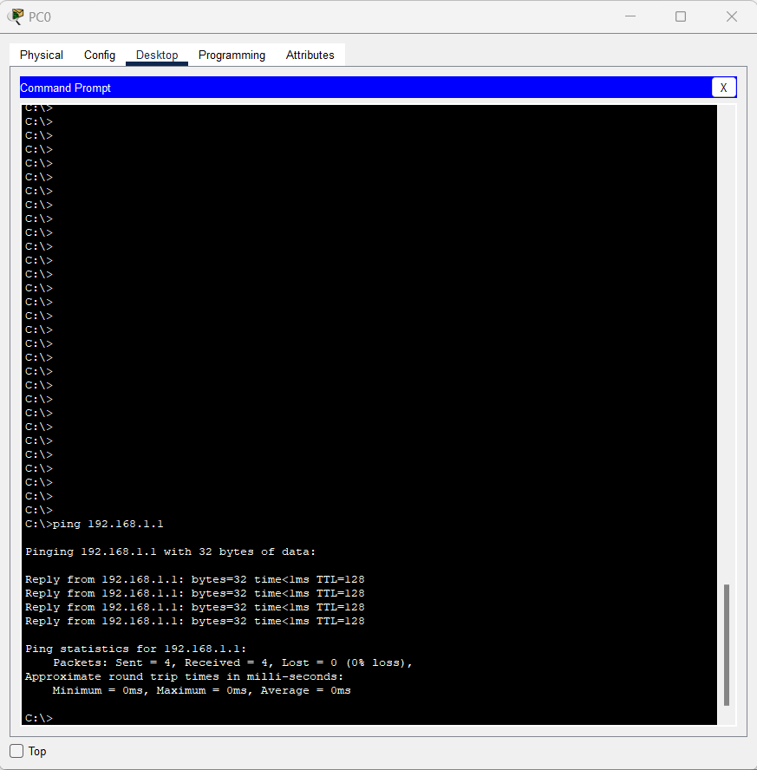

1. For layer 3 switches to be able to route traffic dynamically, IP routing must be enabled.   
   We will use the routing protocol EIGRP (Enhanced Interior Gateway Routing Protocol).   
     
   Configure switch0 with the following commands to enable EIGRP.

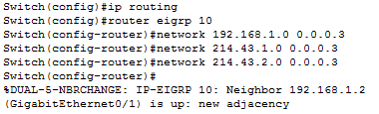



1. We will now configure the EIGRP protocol on switch1 with the same commands as we did in step 10 for switch0

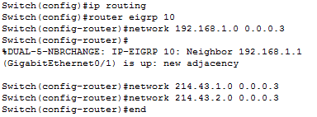



1. You should be able to ping (layer 3 address) from PC0 → PC3. If not, check the configurations. Insert a screenshot of your successful ping below.

